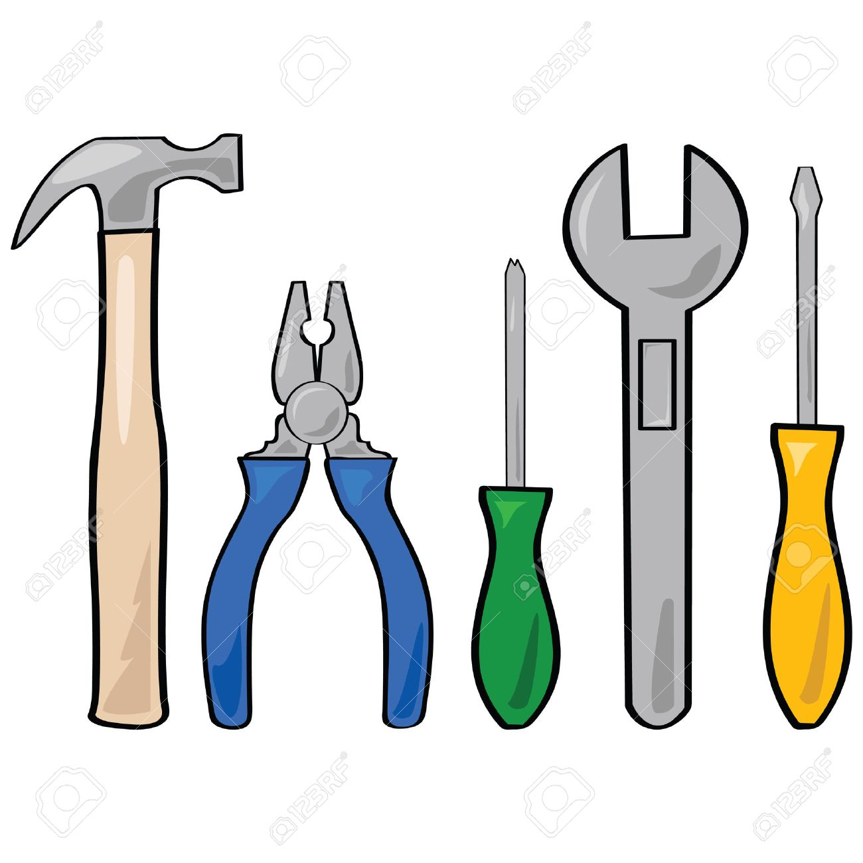



**BE PREDICTABLE**

**AUTHENTICITY**



**TAKE CARE OF YOURSELF**

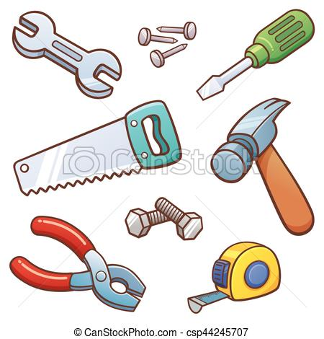

**INTERPRET MILDLY**



**NO PUNISHING OR REWARDING**



**EMOTIONS ARE OK**



**LONG-TERM GOALS**

**TOOLBOX MILD UPBRINGING:**

